**Submitted by: Submitted to:**

**NAME: Rahul Gusain Dr. Hitesh Kumar Sharma**

**SAP: 500084143**

**ROLL NO.: R214220900**

**BATCH: 1 DevOps**

# Build and Release Management

**LAB EXERCISE 7**

**Aim:** Selenium IDE

Perform Automation testing using Selenium IDE for testing a web page.

—Test Blackboard Login Web Page using Selenium Web Driver

**Step 1:-** Open google chrome and search for Selenium IDE extension .

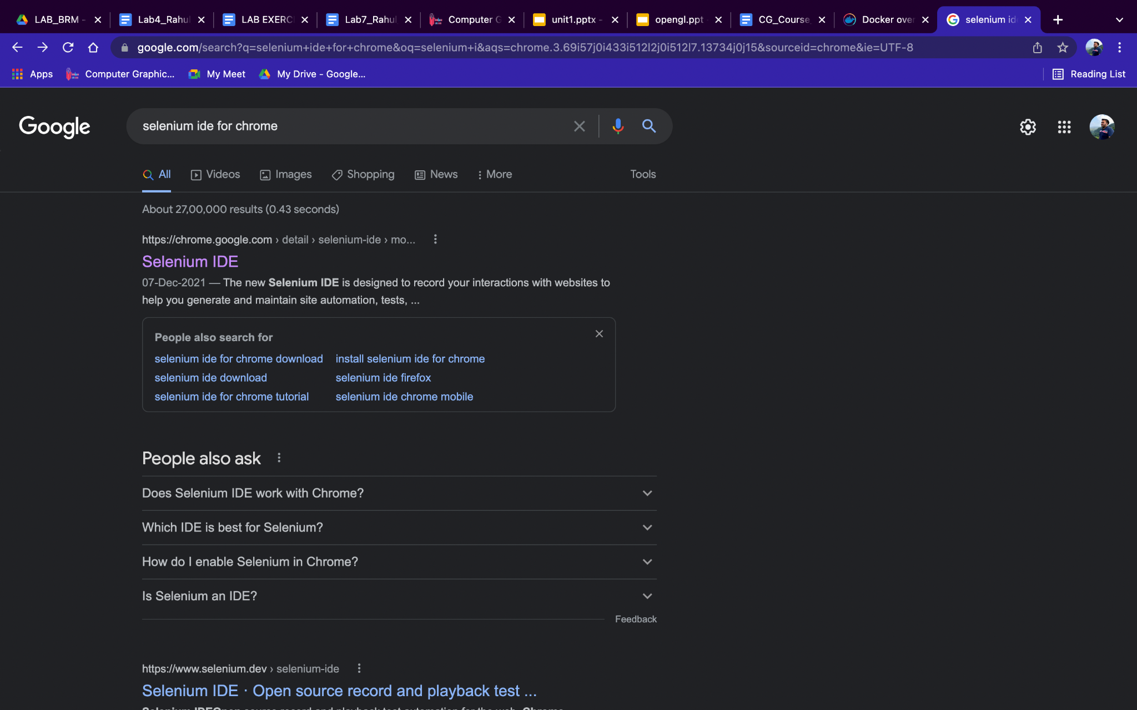

**Step 2:-** Click on the first site that appears and then click on the ‘Add to Chrome button’.

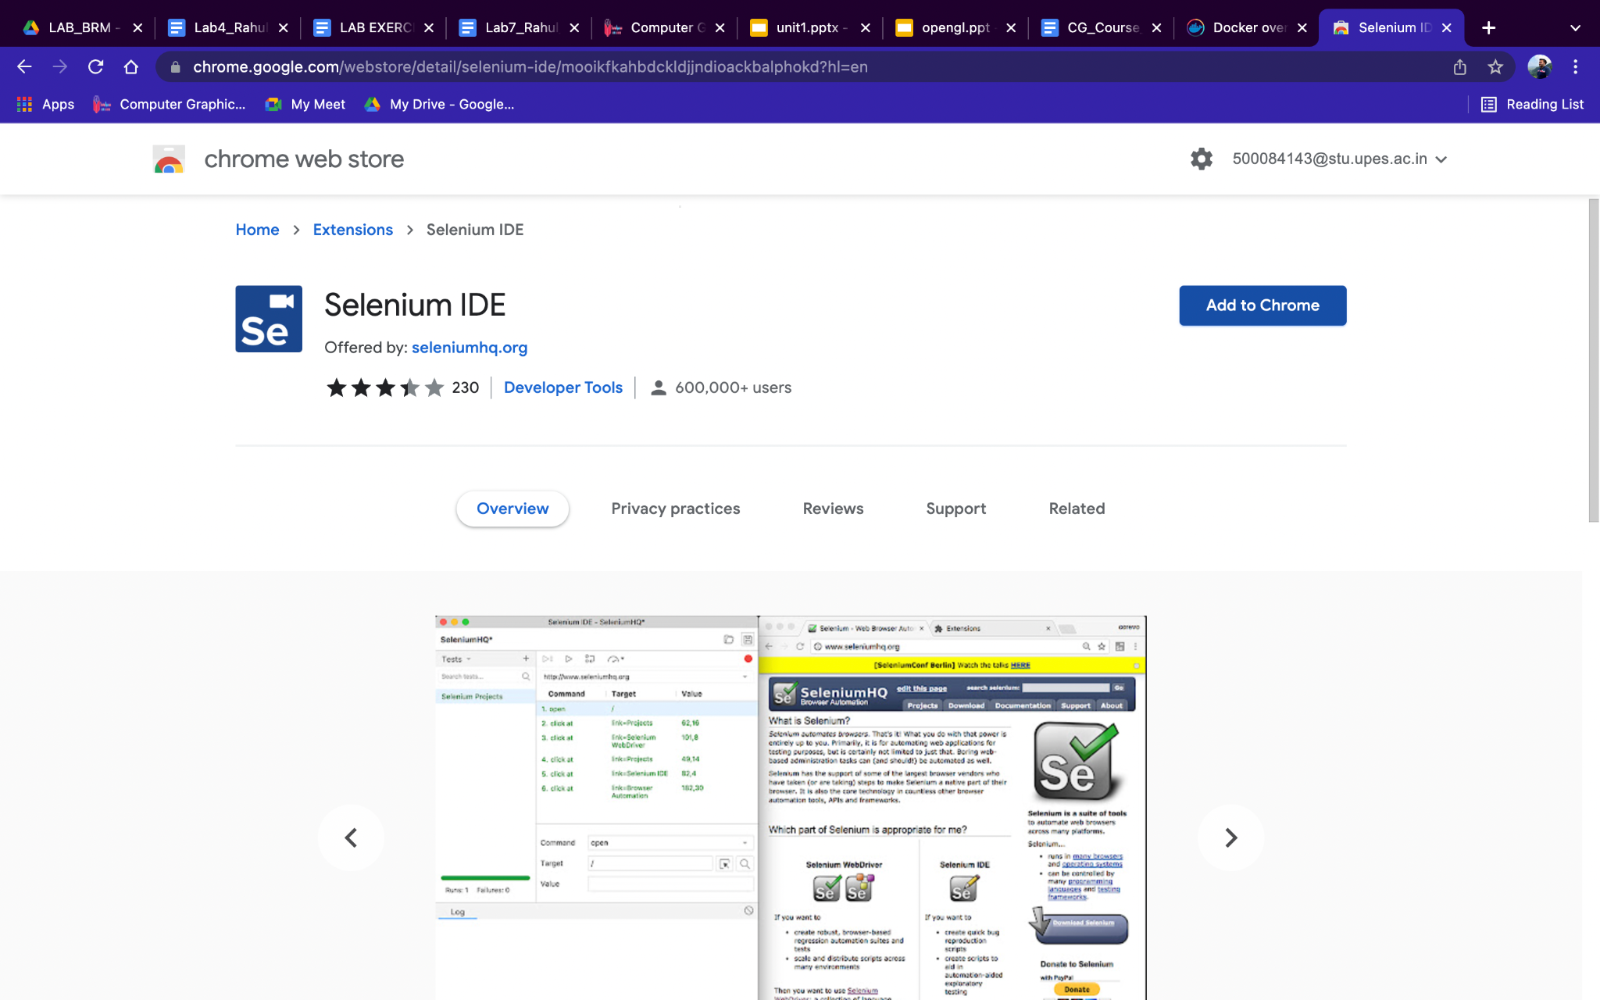

**Step 3:-** Click on ‘Add Extension’ on the dialog box that appears .

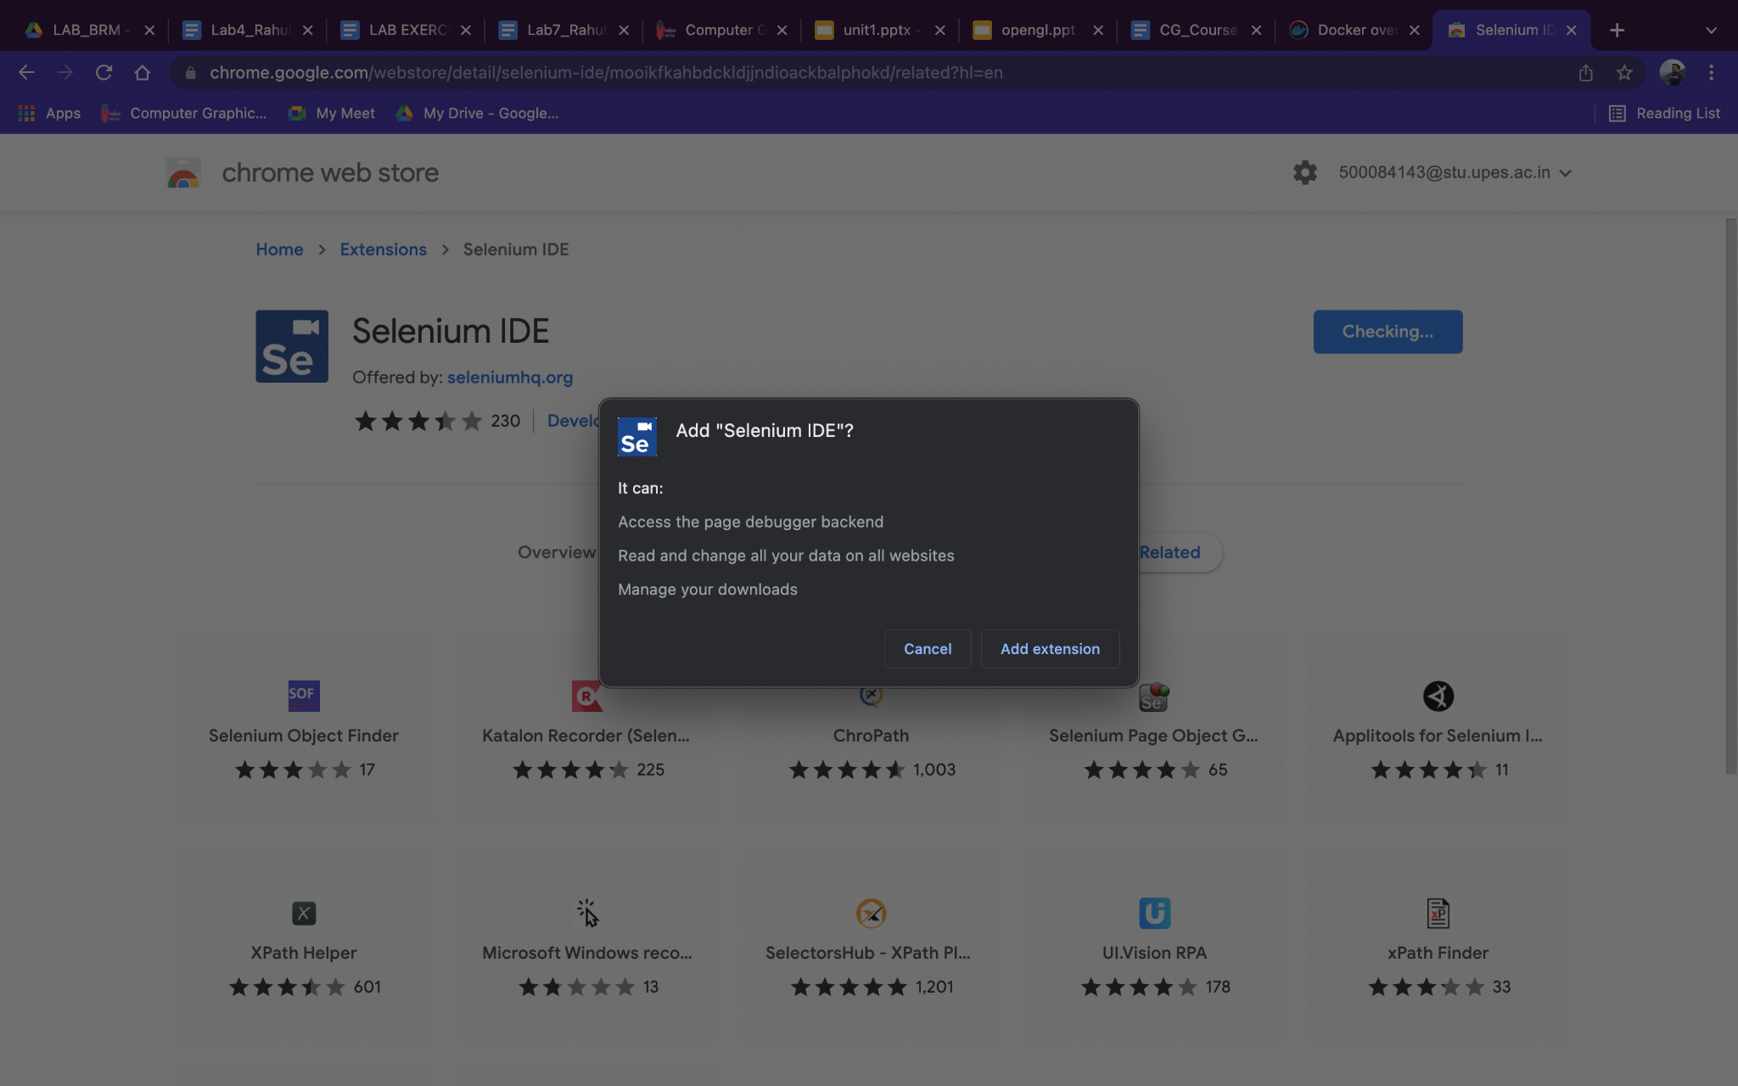

**Step 4:-**  After adding the extension click on the icon present next to starred tabs .

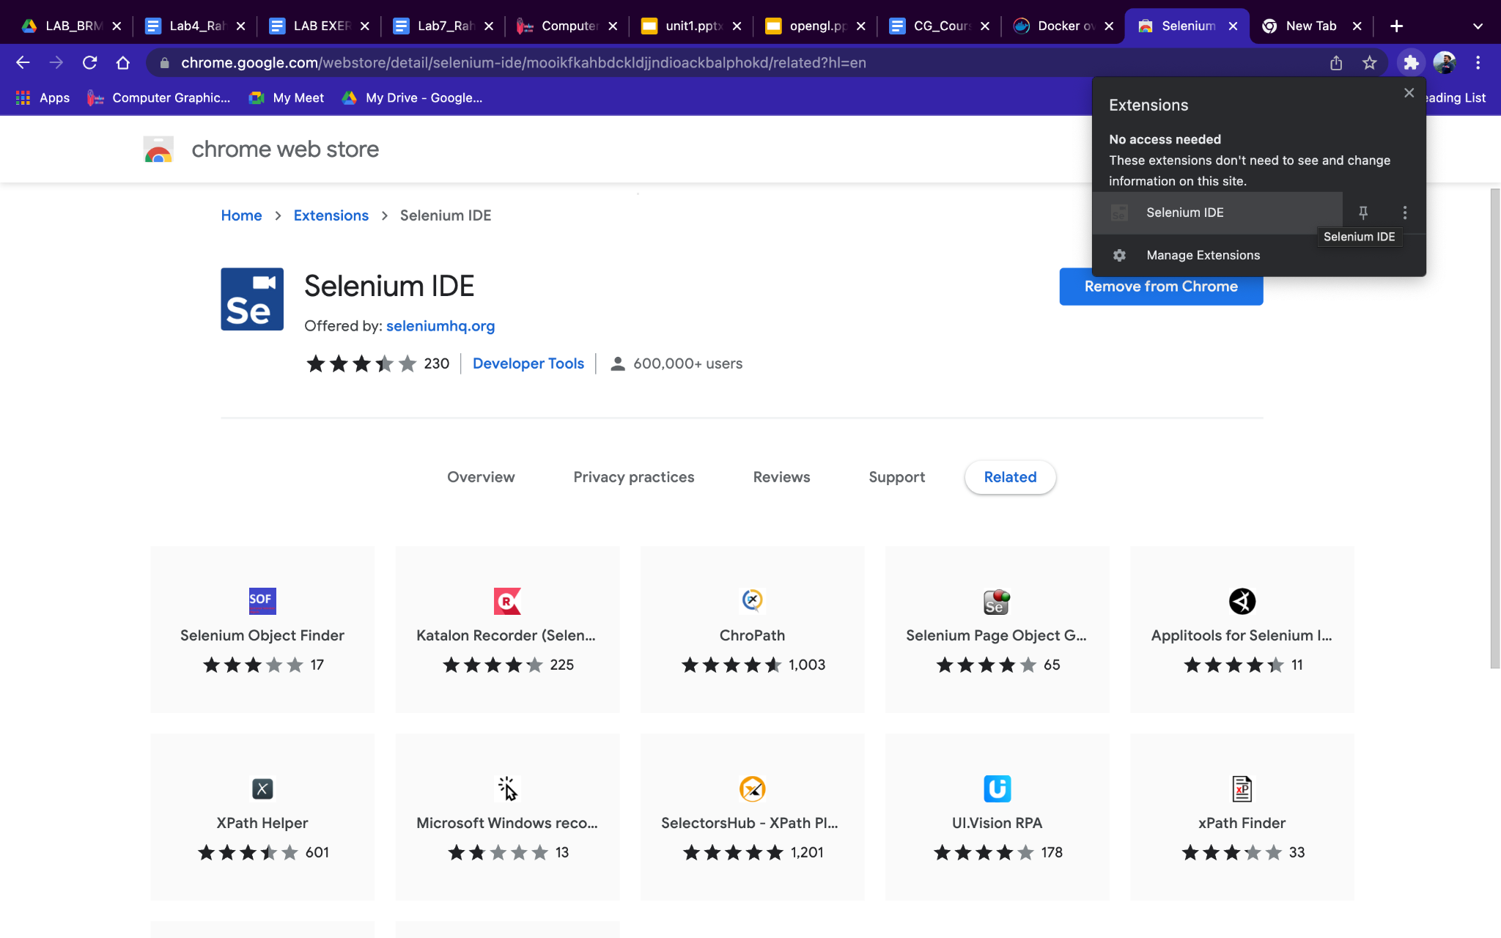

**Step5:-** After clicking on the Selenium Icon box , a new window will appear and it will take you to the Selenium IDE.

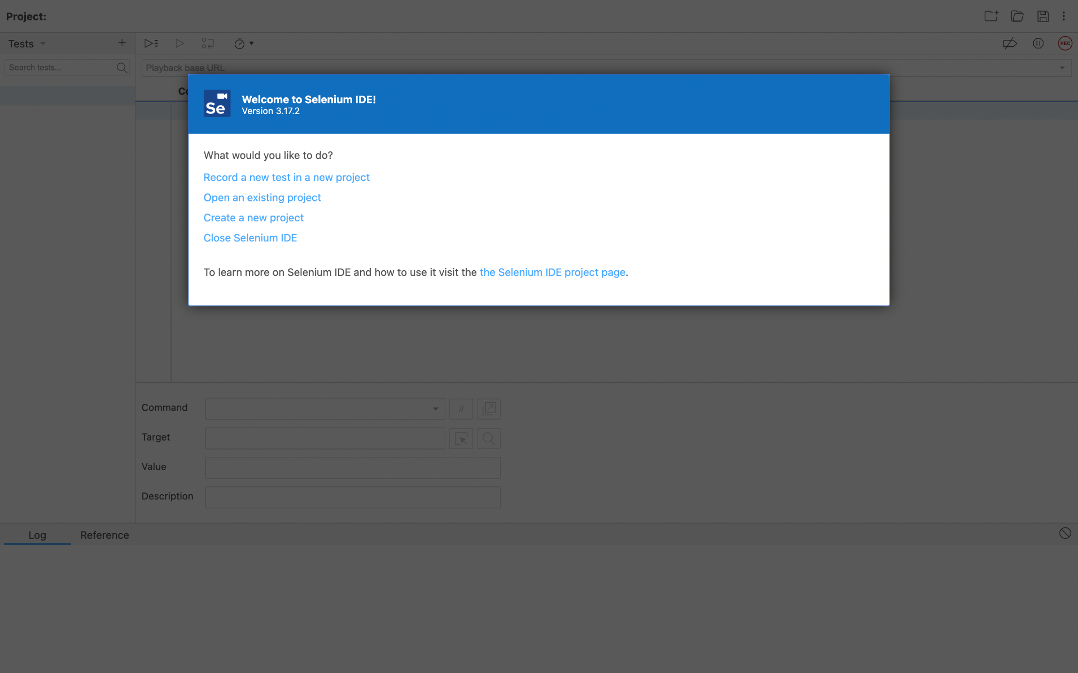

**Step 6:-** Click on the ‘Create a new project’ option and provide the name to the new project.

PROJECT NAME- **Lab_7_Selenium**

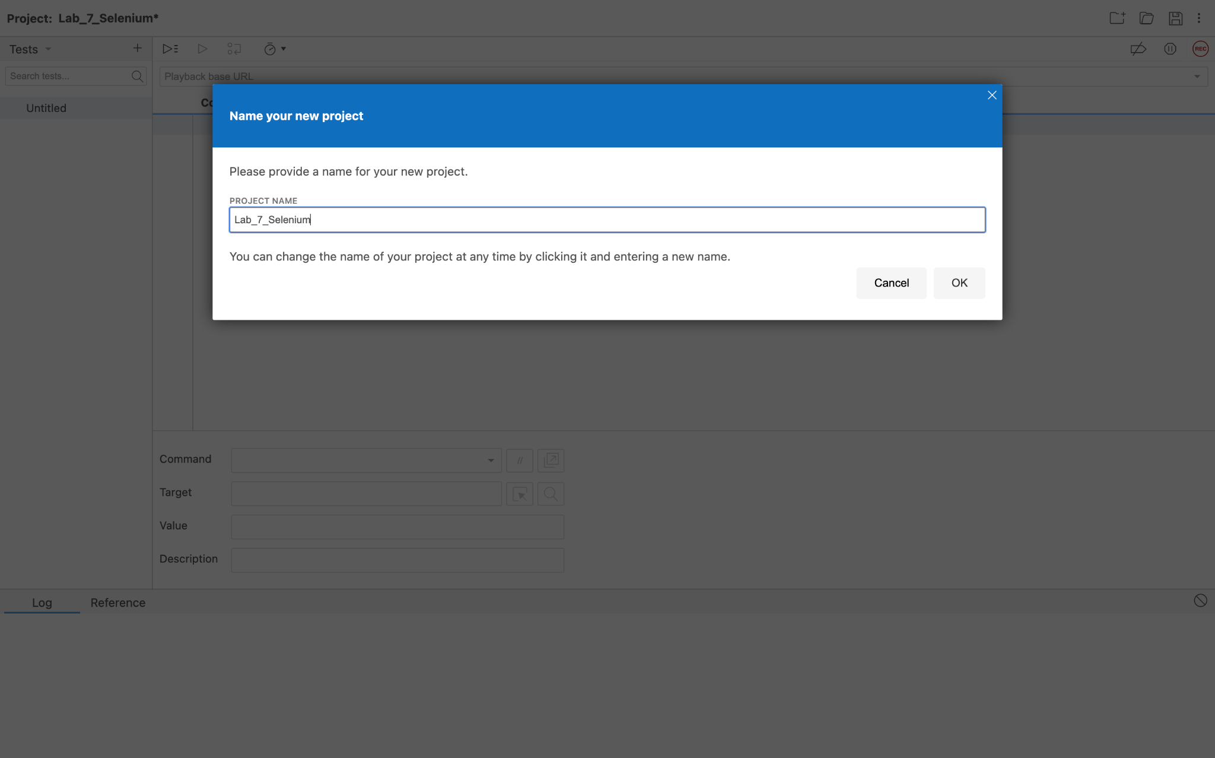

**Step 7:-** Rename the test case according to the need.

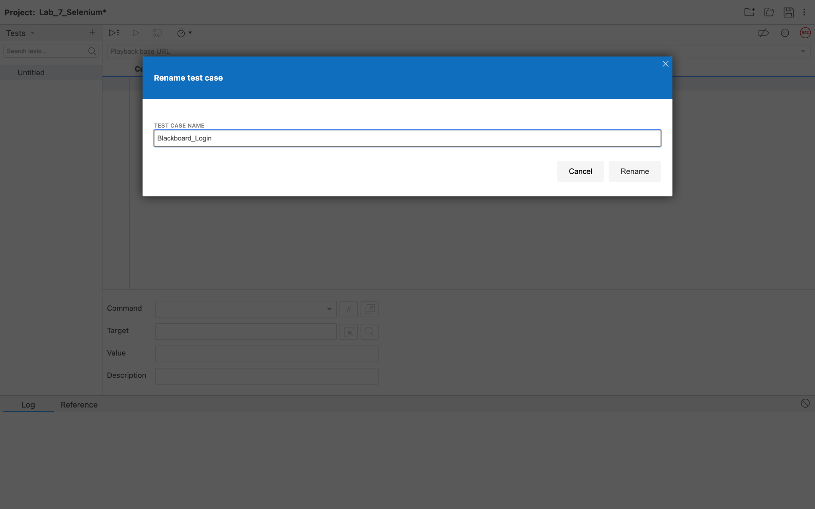

**Step 8:-** Add command , target and value accordingly ,save the command by clicking on the play button which runs the current test .Keep repeating the process for the entire task which is to be automated.

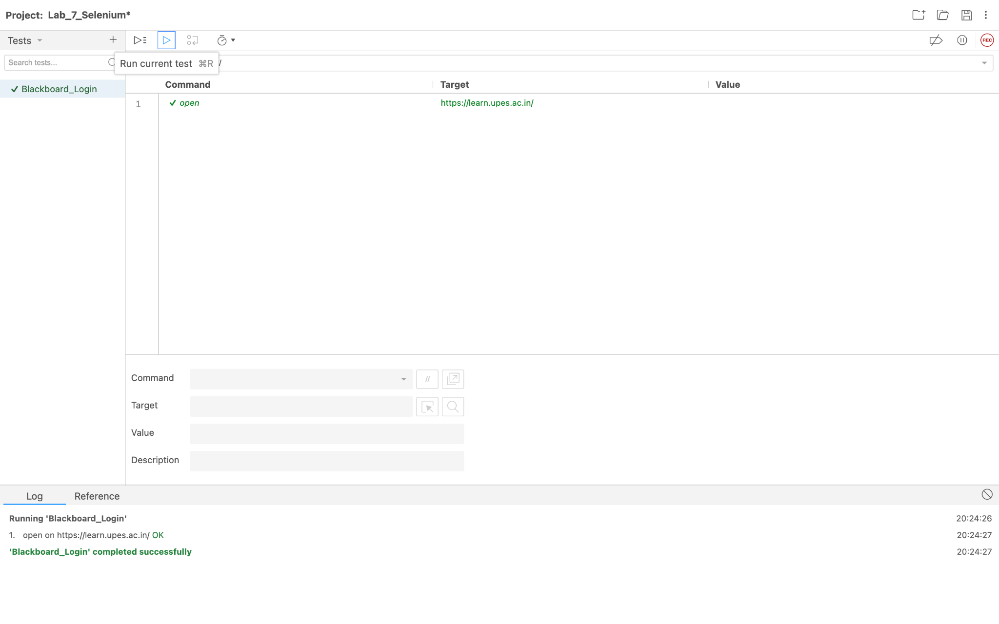

**Step 9:-** After adding all the tasks click on run current test and the test case will run.It will show that the test case is completed successfully.

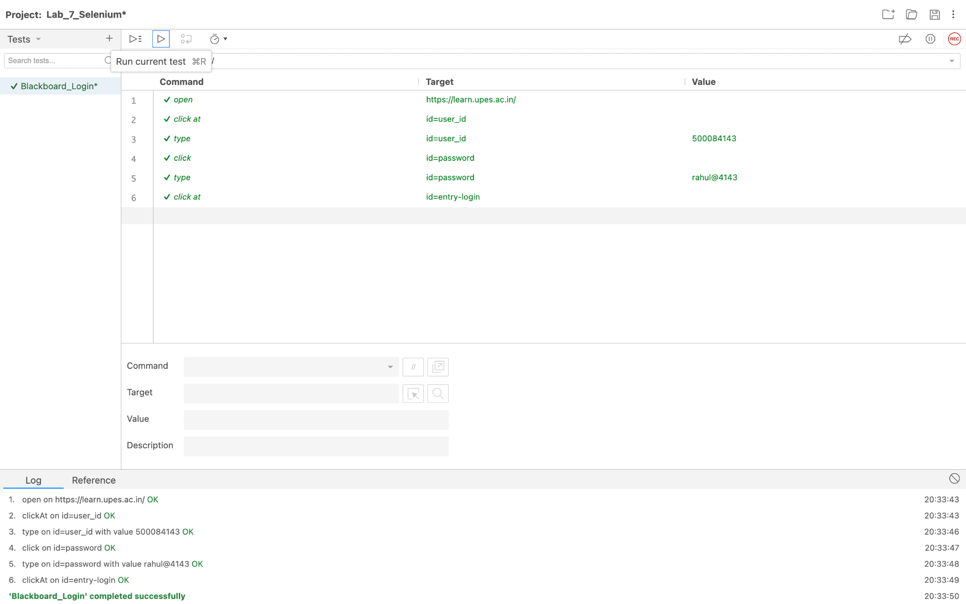

**Step 10 :-** Now the test case Blackboard_login will run and will automatically open the login window with the account logged in .

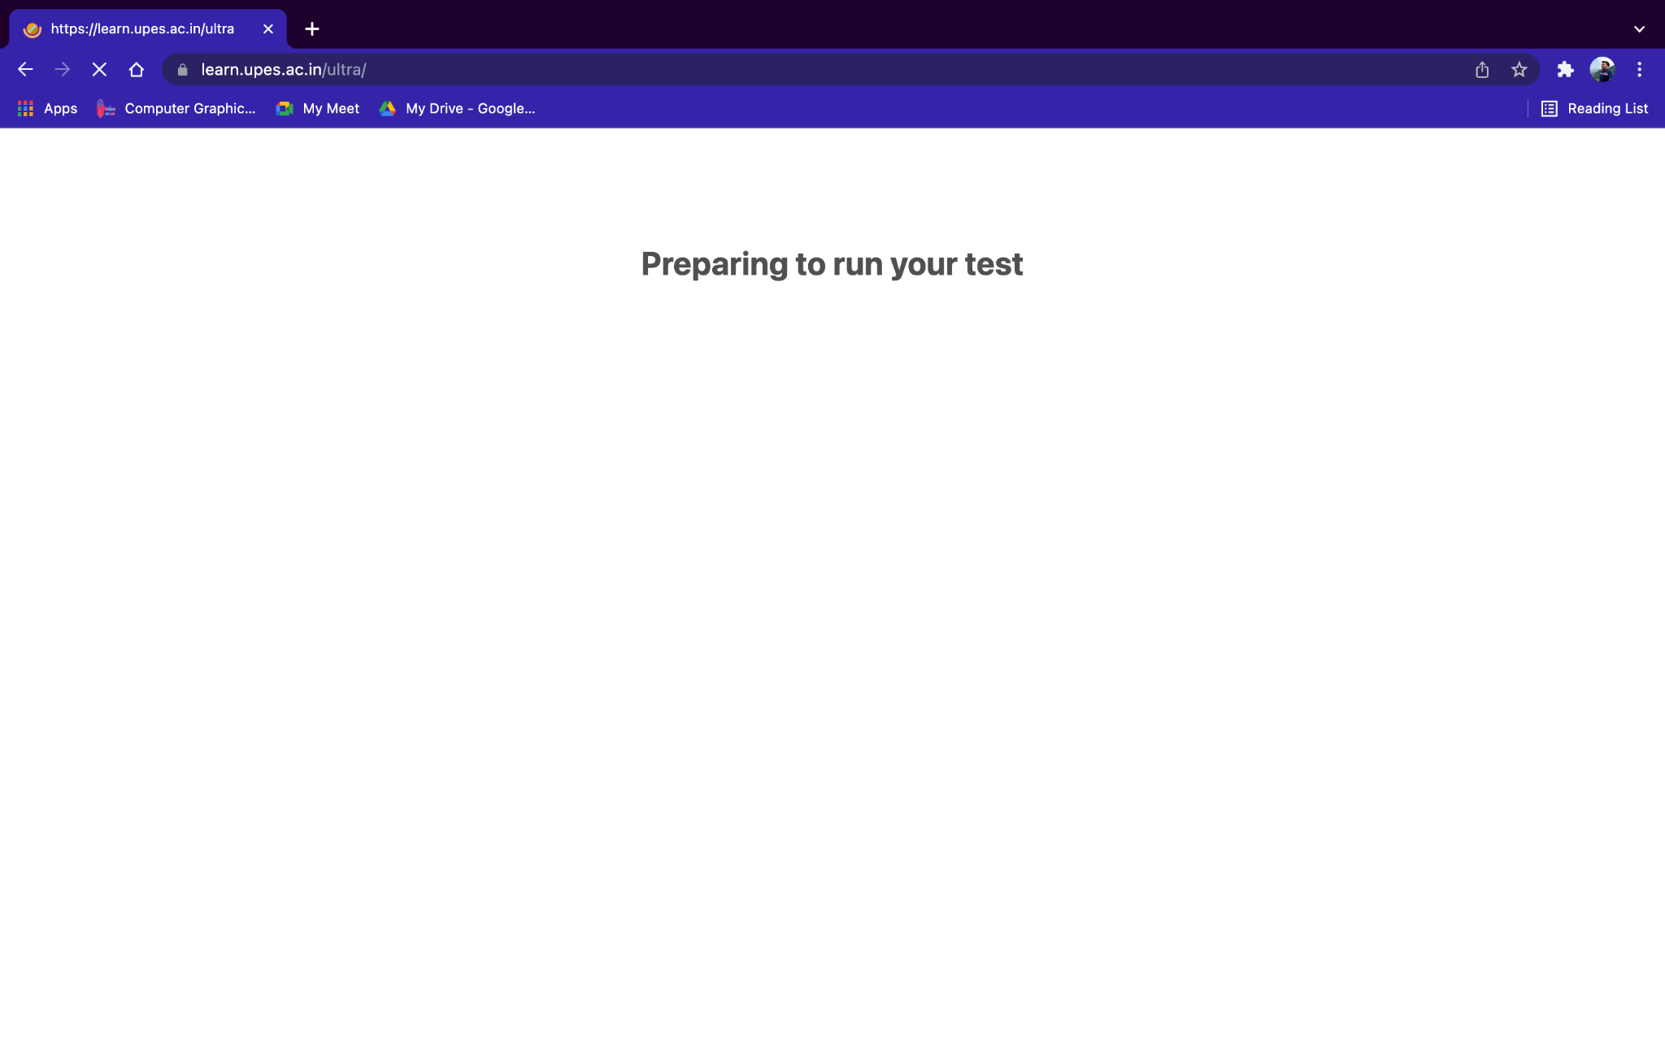

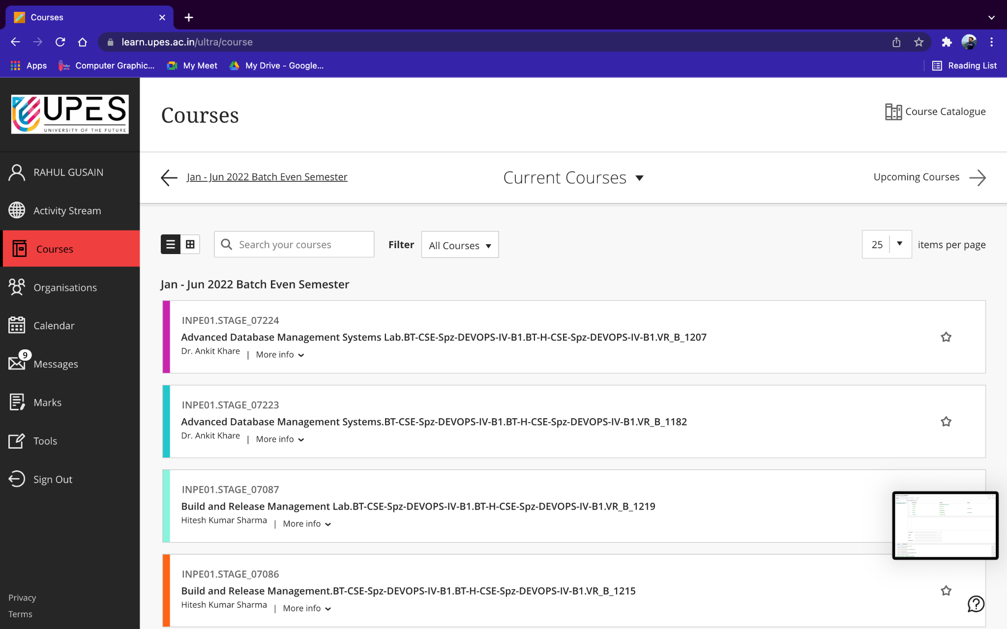

**Step 11:-** Create a new project to show automation using the selenium recording feature.

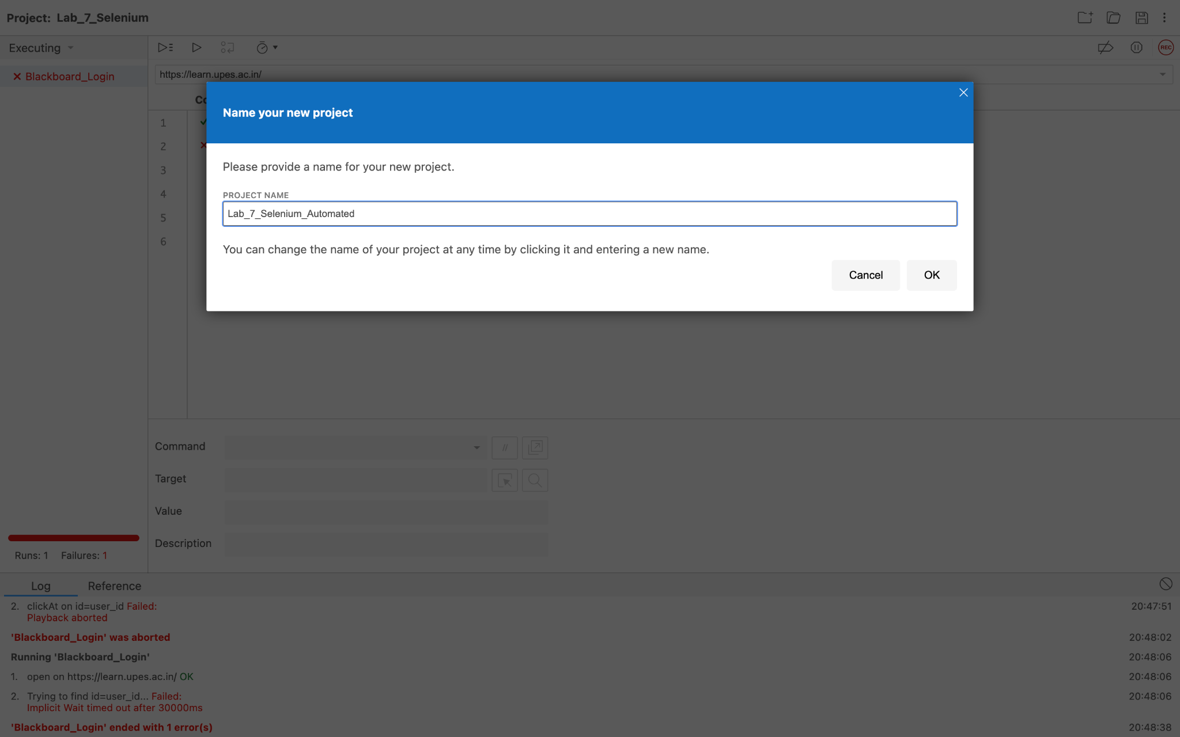

**Step 12:-** Rename the test case and then click on the REC icon to start recording the steps which we want in our test case.

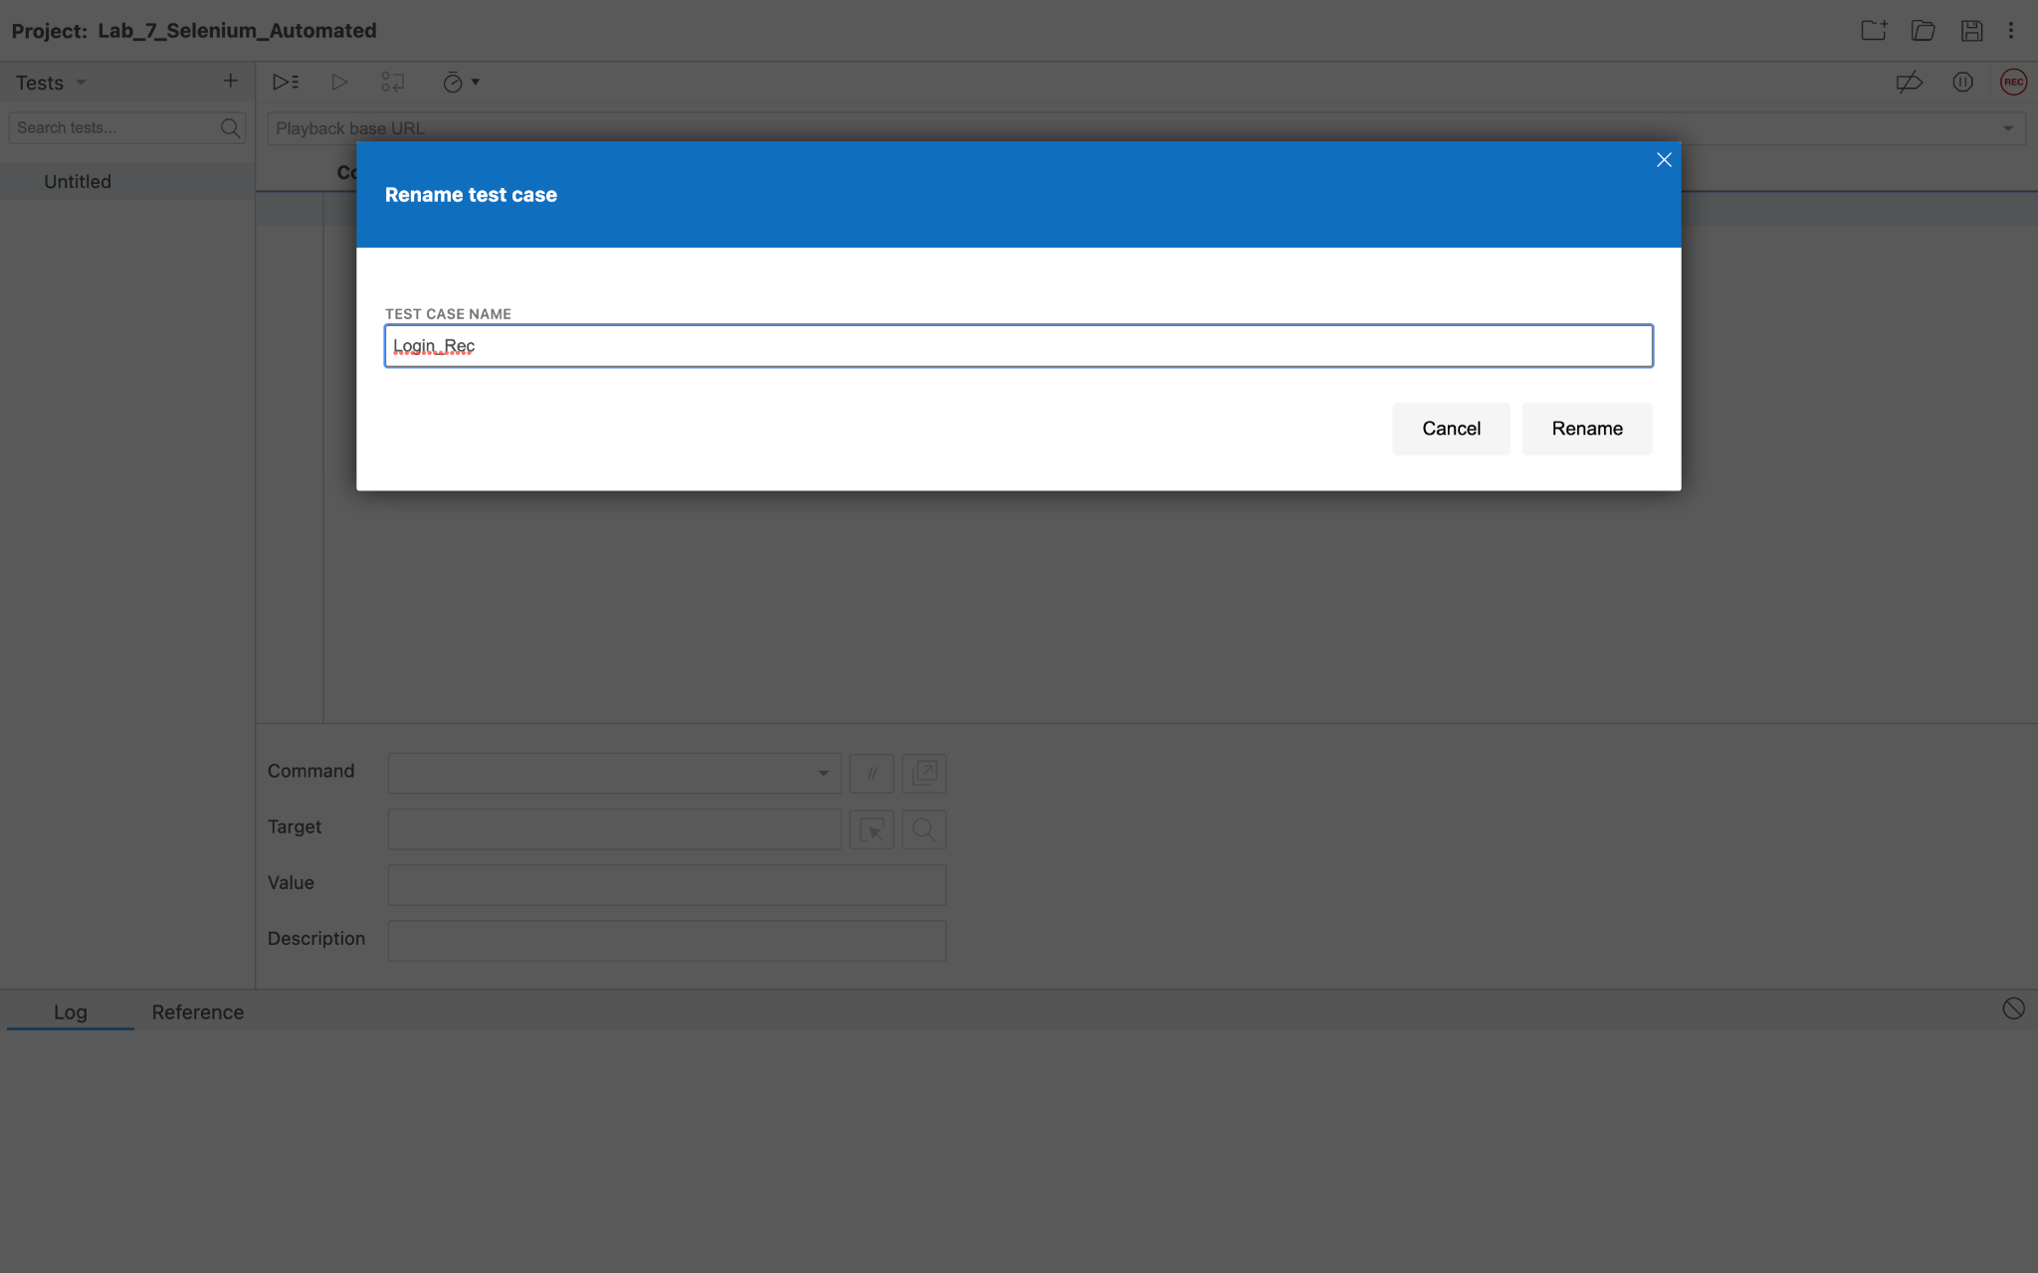

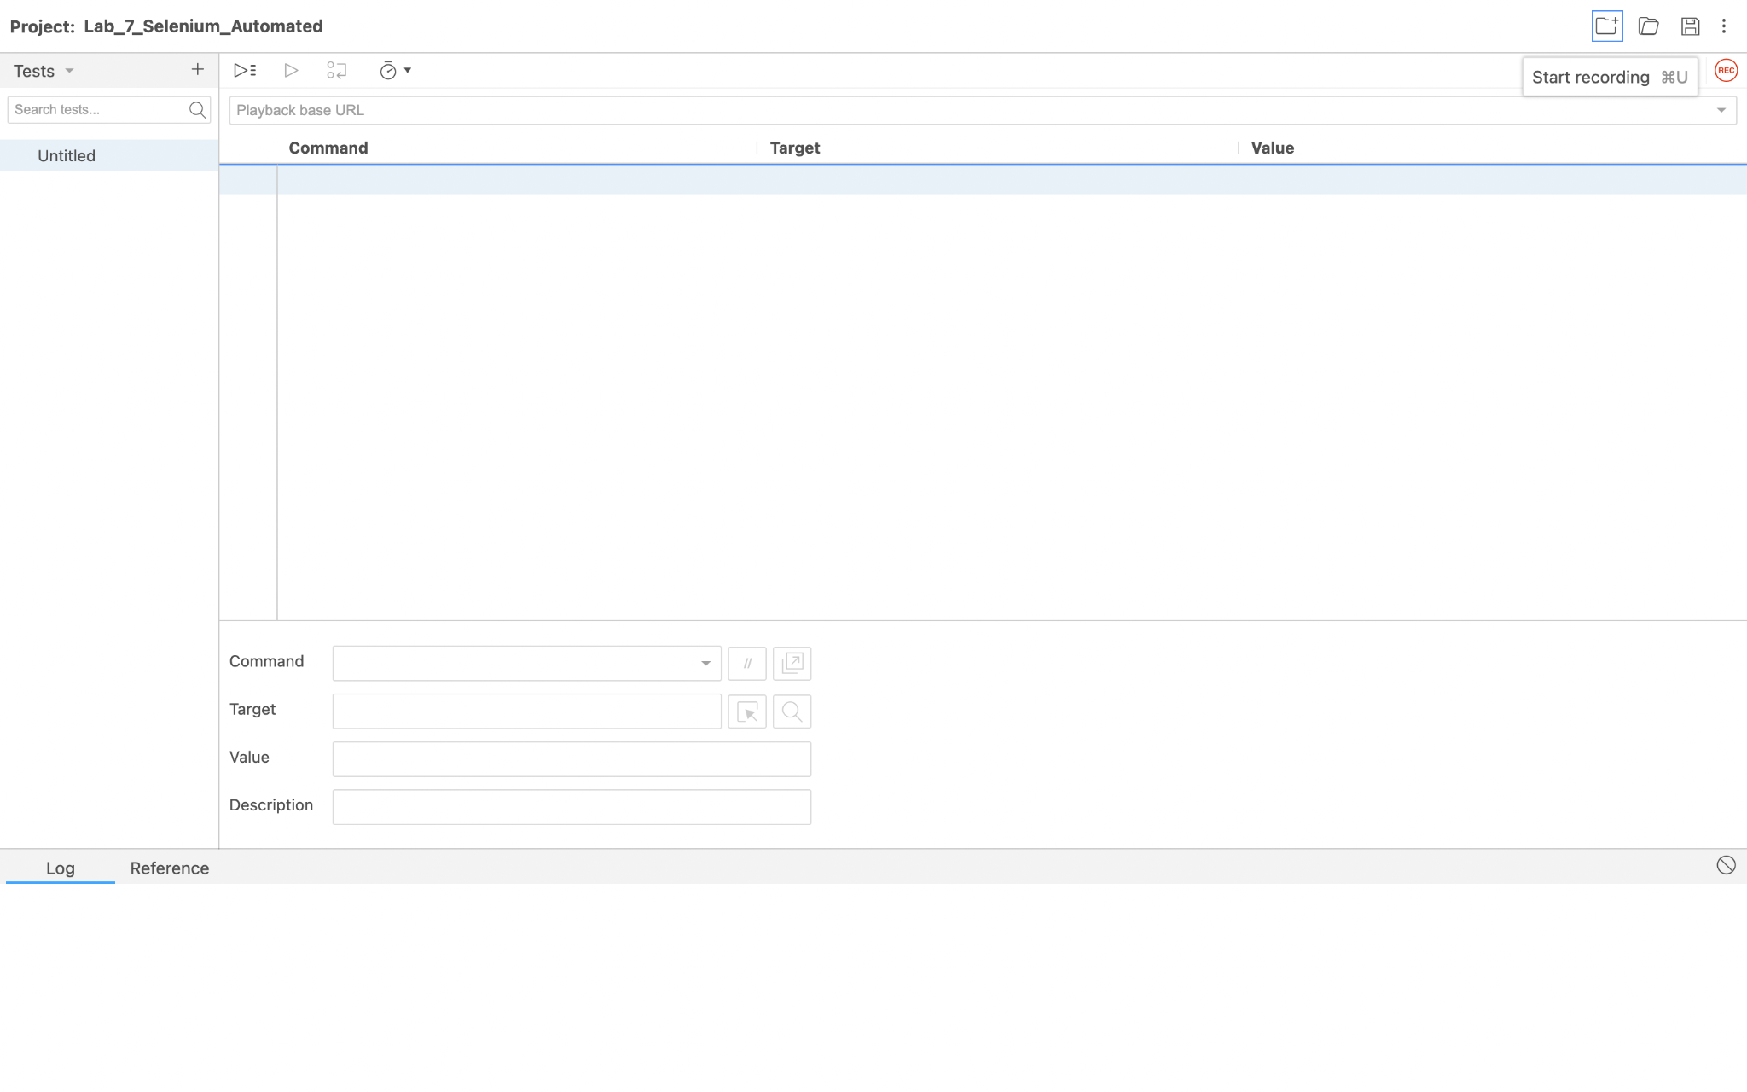

**Step 13:- A**ll the steps will be added to the test case and we can hence automate this process .Selenium IDE will record each and every action and will detect the various actions and will use them ahead in future.

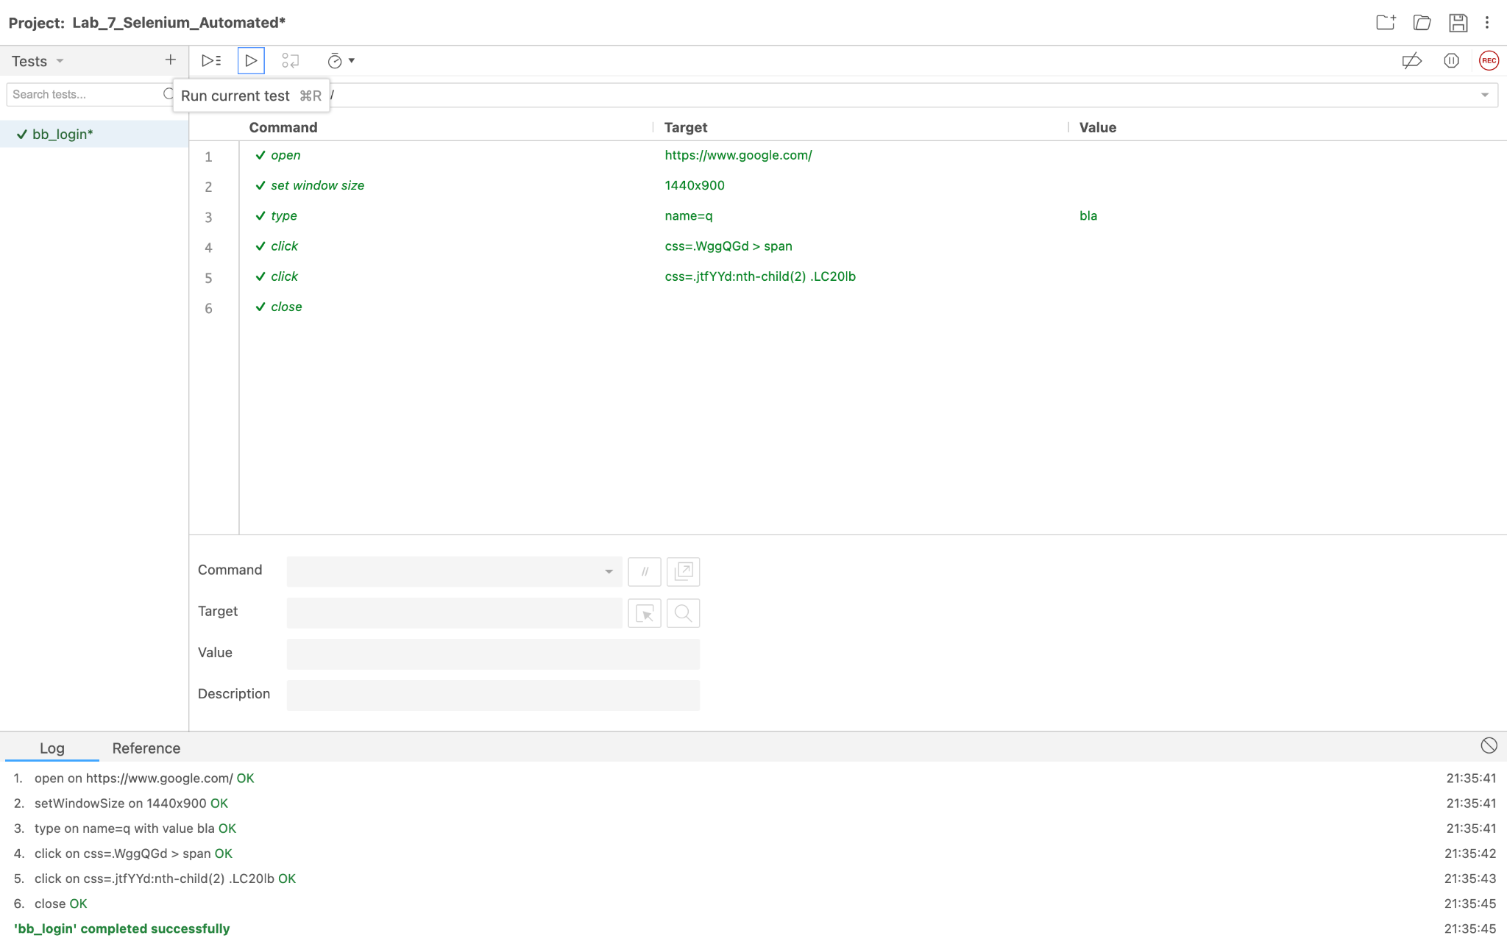

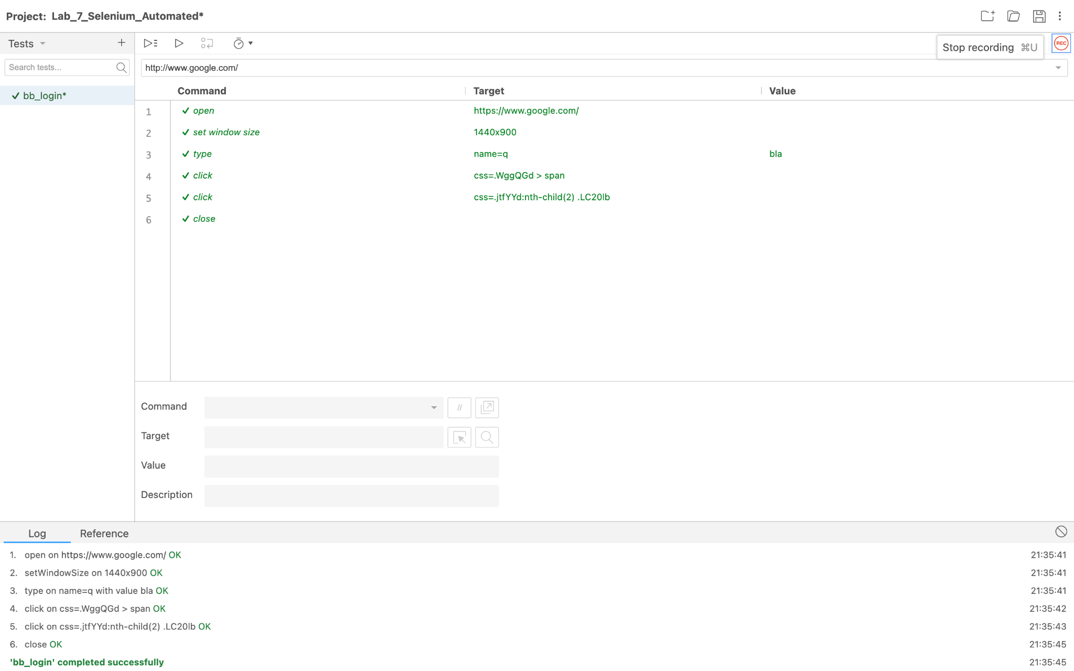

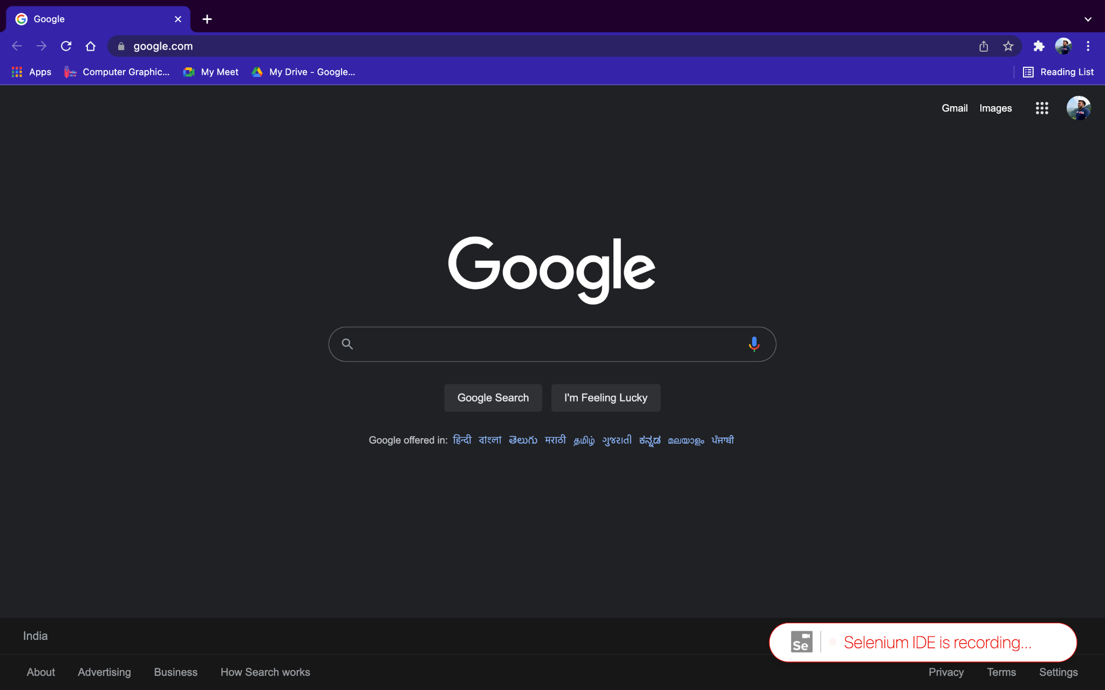

We can see that the window is showing Selenium IDE is recording ... on the screen.

**SPECIAL CASE OF FAILURE:-** Here we are trying to send a mail using Selenium IDE but it shows a failure because for composing a mail the active window shifts to the pop up window which appears to write mail and the IDE is not able to read it hence resulting in its failure.

